FitFlex: Your Personal Fitness Companion
(React Application)

TEAM MEMBERS:
- REHANA SULTANA.S (Entire project folder, documentation)
- LAVANYA.S (Diagrams)
- DHAANLAKSHMI.K (Setup interface)
- UPPU BHARGAVI (Styling)

TABLES OF CONTENT
CHAPTER | TITLE
1. | INTRODUCTION
2. | PROJECT OVERVIEW  2.1 PURPOSE  2.2 FEATURES
3. | ARCHITECTURE  3.1 COMPONENT STRUCTURE  3.2 STATE MANAGEMENT  3.3 ROUTING
4. | SETUP INSTRUCTIONS  4.1 PREREQUISITES  4.2 INSTALLATION
5. | FOLDER STRUCTURE  5.1 CLIENT  5.2 UTILITIES
6. | RUNNIG THE APPLICATION  6.1 FRONTEND
7. | COMPONENET DOCUMENTATION  7.1 KEY FEATURES  7.2 REUSABLE COMPONENTS
8. | STATE MANAGEMENT  8.1 GLOBAL STATE  8.2 LOCAL STATE
9. | USER INTERFACE
10. | STYLING  10.1 CSS FRAMEWORK  10.2 THEMING
11. | TESTING  11.1 TESTING STRATEGY  11.2 CODE COVERAGE
12. | SCREENSHOTS OR DEMO
13. | KNOWN ISSUES
14. | FUTURE ENHANCEMENT

1.INTRODUCTION
FitFlex: Your Personal Fitness Companion is a dynamic and intuitive fitness application designed to provide users with a personalized and engaging workout experience. Developed using React for the web and React Native for mobile platforms, FitFlex empowers users to achieve their fitness goals through customized workout plans, real-time progress tracking, and comprehensive exercise information. Whether you're a beginner or an experienced athlete, the app tailors its recommendations based on your fitness level, preferences, and available equipment.
The platform offers a variety of workout categories, including cardio, strength training, yoga, and flexibility exercises, which can be easily searched and filtered according to specific criteria such as muscle group, difficulty, and equipment requirements. Each exercise is accompanied by detailed instructions, visual demonstrations, and expert tips to ensure proper form and safety.
In today’s fast-paced world, maintaining a healthy and active lifestyle can be challenging. That's where FitFlex comes in—your ultimate fitness companion, designed to help you stay motivated, track your progress, and achieve your personal fitness goals with ease. Whether you’re just starting your fitness journey or are a seasoned athlete, FitFlex adapts to your needs, offering personalized workout plans, easy navigation, and expert guidance every step of the way.
FitFlex is built to provide a comprehensive and engaging fitness experience. With features like dynamic workout recommendations, detailed exercise instructions, and a wide range of categories—from cardio and strength training to yoga and flexibility—FitFlex ensures that there's something for everyone. Its powerful search functionality makes it easy to find exercises that suit your fitness level, goals, and available equipment.
The app is designed to keep you motivated with trending fitness challenges, progress tracking, and personalized workout suggestions. FitFlex not only helps you get fit but also keeps you engaged, inspired, and connected to a community of like-minded individuals.
Whether you're looking to tone up, build strength, improve flexibility, or simply stay active, FitFlex: Your Personal Fitness Companion is here to guide, inspire, and support you throughout your fitness journey. Your goals are just a workout away!

2.PROJECT OVERVIEW
FitFlex is a modern and intuitive React-based web application designed to provide users with a personalized fitness experience. This app offers a variety of features to help users achieve their fitness goals, track progress, and receive tailored workout and nutrition recommendations. FitFlex is built to be a companion in every user’s fitness journey, whether they are beginners or seasoned athletes.
2.1 PURPOSE
The primary purpose of FitFlex is to provide individuals with a personalized and accessible fitness companion that guides them through their fitness journey. Whether a user is looking to lose weight, build muscle, improve overall health, or simply stay active, FitFlex aims to make fitness more engaging, achievable, and sustainable. The app empowers users to take control of their health and well-being by offering tailored workout plans, nutrition advice, and progress tracking in a single platform.
Expanded Purpose of FitFlex:
- Empowering Individuals to Take Control of Their Fitness: FitFlex aims to empower users by giving them the tools, knowledge, and resources to take charge of their health and fitness journey. Rather than relying on vague or generic advice, FitFlex provides specific, actionable plans and recommendations tailored to each user’s individual goals, fitness level, and lifestyle.
- Breaking Down Barriers to Fitness: Many individuals struggle with starting or maintaining a fitness routine due to lack of knowledge, time, or motivation. FitFlex breaks down these barriers by offering:
  - User-Friendly Interface: Easy-to-navigate features that help even beginners set up their fitness plans quickly.
  - Flexible Schedules: Customizable workout plans that can be adjusted to users’ availability and goals.
  - No Equipment Necessary: Options for bodyweight exercises that require no gym equipment, making it accessible to everyone, anywhere.
- Promoting Long-Term Lifestyle Changes: FitFlex isn't just about short-term fitness goals. The app's purpose is to encourage lasting lifestyle changes by:
  - Encouraging users to integrate healthy habits gradually.
  - Helping users set both short-term milestones (e.g., "Lose 5 pounds") and long-term goals (e.g., "Achieve consistent strength training routine").
    - Reinforcing the importance of consistent progress tracking and accountability, helping users stick with their fitness journeys over time.
- Holistic Approach to Fitness: FitFlex recognizes that fitness is not just about exercise. It takes a holistic approach, which combines:
  - Physical Activity: Personalized workout plans that are varied and designed for all fitness levels.
  - Nutrition: Healthy, balanced meal plans that align with users’ goals (e.g., weight loss, muscle building, energy).
  - Mental Wellness: Encouraging users to stay mentally engaged by tracking their moods, energy, and motivation levels, and offering tips to combat burnout or plateaus.
2.2 KEY FEATURES
Key purposes of FitFlex include:
• Personalization:
To offer customized workout routines, meal plans, and fitness goals based on the user’s specific needs, fitness level, and preferences.
• Motivation & Accountability:
To provide users with daily reminders, progress tracking, and goal setting, helping them stay motivated and accountable to their fitness commitments.
• Accessibility:
To make fitness accessible for everyone, regardless of experience or background, by offering easy-to-follow exercises, beginner-friendly tips, and flexible meal plans.
• Tracking & Progress Monitoring:
To enable users to track their workouts, progress, and nutrition over time, offering insights into their • improvement and achievements.
• Community & Social Interaction:
To foster a sense of community by allowing users to share progress, engage in fitness challenges, and support each other.

3.ARCHITECTURE
The architecture of FitFlex is designed to be scalable, modular, and maintainable, ensuring the web application is both efficient and flexible for future enhancements. The architecture follows modern best practices in web development, leveraging a client-server model with clear separation of concerns, responsive design, and integration with various external services (e.g., social media, wearables).
Key Components of the Architecture:
1. Frontend (Client-Side) - React.js:
The frontend of FitFlex is built using React.js, a modern JavaScript library for building user interfaces. React’s component-based architecture allows for a modular design where different features of the app are encapsulated in individual, reusable components.
Core Components:
- UI Components (React Components): Each page or feature is made of React components like buttons, forms, navigation bars, workout plans, progress charts, and meal tracking.
  - Homepage: Displays app features and encourages sign-up/login.
  - Dashboard: The main interface showing personalized workout plans, progress, and recommendations.
  - Workout Planner: Displays daily workout routines, with exercise instructions, images, and videos.
  - Meal Planner: Displays nutrition recommendations and logs.
  - Progress Tracker: Displays charts and graphs to track fitness progress.
- State Management (Redux or React Context): Global application state (e.g., user data, workout plans, progress) is managed using Redux or React Context API.
  - Redux is useful for managing complex states and large-scale data, such as user preferences, workout progress, etc.
- Routing (React Router): To handle multiple views/pages within the app (e.g., Dashboard, Profile, Login).
- User Authentication: Authentication is managed using Firebase Authentication or Auth0, providing secure login with email/password, social media accounts (Google, Facebook), or custom solutions.
Libraries and Tools:
- Axios or Fetch API: For making API calls to the backend server for user data, workout plans, and progress logging.
- Chart.js or D3.js: For data visualization to show progress (e.g., weight loss, calories burned, muscle gain) through graphs and charts.
UI/UX Design:
- Material-UI or TailwindCSS: For pre-styled components and responsive design, ensuring the app works seamlessly across devices (desktop, tablet, mobile).
- Responsive Design: The frontend is built to be responsive, ensuring a great user experience on both desktop and mobile devices.

2. Backend (Server-Side) - Node.js and Express.js:
The backend of FitFlex handles all business logic, data storage, user authentication, and communication with the frontend.
Core Components:
- Node.js: The backend server is built using Node.js, a JavaScript runtime, to handle server-side operations.
- Express.js: A minimalist web framework for Node.js that helps manage HTTP requests, routing, and middleware for handling logic like authentication, user data management, etc.
Key Backend Features:
- User Authentication and Authorization:
  - JWT Tokens: After successful login, the backend generates a JWT (JSON Web Token) to authenticate requests from the frontend.
  - OAuth Authentication: Integration with Google/Facebook for easy login and user registration.
- APIs:
  - RESTful API endpoints are designed to handle CRUD operations (Create, Read, Update, Delete) for features like workouts, meal plans, progress tracking, and user data.
  - Example endpoints include /api/user, /api/workouts, /api/meal-plans, /api/progress, /api/auth, etc.
  - Rate Limiting and Caching: Using tools like Redis or APCU to improve performance and prevent abuse (especially for API calls like fetching workout routines or meal plans).
- Data Validation & Security:
  - Helmet (security middleware for Express.js) for basic security practices (e.g., preventing cross-site scripting attacks).
  - Data Validation: Ensuring that only valid data is sent to the server (e.g., using Joi or Express Validator).

3. Database:
FitFlex needs a robust database to store user data, progress, workouts, and nutrition plans. The choice of database depends on the type of data and expected load.
- MongoDB (NoSQL) or PostgreSQL (SQL) are the most likely candidates.
  - MongoDB is preferred if we want flexible, schema-less data storage (especially useful for storing workout routines, user preferences, and progress logs).
  - PostgreSQL is preferred if we want structured data with complex relationships, like tracking multiple workout programs and meal plans linked to users.
- Schema Design:
  - Users: Store user details such as email, name, goals, preferences, and authentication tokens.
  - Workouts: Store the workout plans, exercise details (sets, reps, duration), and types (strength, cardio, flexibility).
  - Nutrition: Store meal plans, calorie breakdown, macronutrient information, and meal tracking logs.
  - Progress Logs: Store daily/weekly progress on weight, muscle growth, calories burned, etc.

4. External Integrations:
FitFlex integrates with various external services to enhance the functionality and provide a seamless user experience:
- Fitness Trackers & Wearables:
  - Integration with Fitbit, Apple Health, or Google Fit to sync user data (e.g., step count, calories burned, heart rate).
  - APIs like Google Fit API or Fitbit API are used to fetch activity data directly into the app.
- Social Media Integration:
  - Users can share achievements and workout progress directly to platforms like Facebook, Instagram, or Twitter.
  - Use of OAuth for social logins and API integrations for sharing.
- Payment Gateway (Optional for Premium Features):
  - Integration with Stripe or PayPal to handle subscription payments for premium features (e.g., advanced workout plans, personalized coaching, premium recipes).

5. Cloud and Hosting:
- Frontend Deployment:
  - Vercel or Netlify for serverless deployment of the frontend. These services provide continuous deployment pipelines, easy scaling, and automatic optimizations for React apps.
- Backend Deployment:
  - Heroku or AWS (Amazon Web Services) for hosting the backend server, database, and other microservices.
  - Docker could be used to containerize the backend services for easy deployment and scalability.
- Database Hosting:
  - MongoDB Atlas (for MongoDB) or Amazon RDS (for PostgreSQL) for managed database services to handle scaling and backups.

6. Notifications & Real-Time Features:
- Push Notifications:
  - Use of services like Firebase Cloud Messaging (FCM) or OneSignal to send push notifications for reminders, new workout plans, and progress updates.
- Real-Time Updates (Optional):
  - Socket.io for real-time chat or fitness challenge updates, allowing users to interact with the app in real-time (e.g., challenge updates, progress sharing).

Architecture Diagram (Overview)
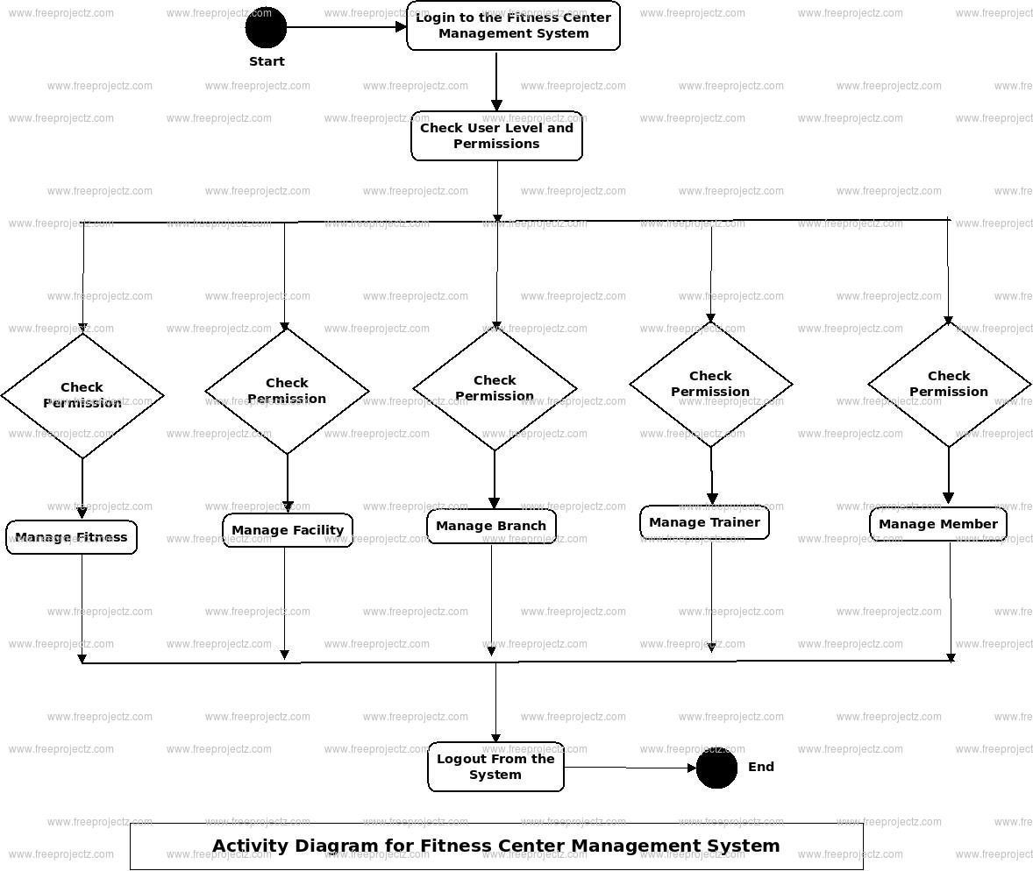
3.1COMPONENT STRUCTURE
To create a component structure for FitFlex, we need to break down the application into logical components that allow for efficient development, maintainability, and scalability. I'll assume FitFlex is a fitness or health-related application that could involve features like user profiles, workouts, tracking progress, goals, etc.
Here's a possible component structure for FitFlex, using a modular approach that organizes components based on different features:
1. Global/Shared Components
These are components that can be used across multiple pages/screens and have no specific relation to any one feature but are required globally in the app.
- Header: Displays app name, navigation links, user profile, or settings.
- Footer: Contains copyright information, legal links, or app-related links.
- Button: A reusable button component with customizable text, color, and actions.
- Input Field: A reusable text input field, with optional validation, for user input.
- Modal: A reusable modal component for showing popups like notifications or forms.
- Toast Notification: Used for success, error, or info alerts.
- Card: A general-purpose card component for displaying information in a structured format.
2. User Profile Section
These components are responsible for managing the user’s personal information, fitness goals, and progress tracking.
- UserProfile: Displays basic user information (name, photo, email, etc.).
- UserStats: Shows key statistics (e.g., weight, steps, calories burned).
- GoalProgress: Displays progress toward fitness goals (e.g., exercise minutes or weight loss).
- EditProfile: Allows the user to edit their profile information.
- ActivityHistory: Displays the user’s past workouts, steps, or activities.
3. Workout Components
These components are responsible for managing workouts, routines, and exercises.
- WorkoutList: A list of available workouts the user can select from.
- WorkoutDetail: Displays detailed information about a particular workout (e.g., exercises involved, duration).
- ExerciseCard: Shows an individual exercise with instructions, sets, reps, etc.
- AddExercise: Allows users to add or customize an exercise within their workout.
- Timer: A timer to track time during the workout or for specific exercises.
4. Progress Tracker
These components track progress in real-time and display results in a structured manner.
- ProgressOverview: A dashboard-style component that shows a quick overview of workout stats and health metrics.
- StepTracker: A component that shows the number of steps the user has taken (if using wearable or app integration).
- WeightTracker: A component that displays the user's weight over time.
- CaloriesTracker: A component that tracks calories consumed and burned.
5. Nutrition & Meal Planning
These components handle meal tracking, recipes, and nutritional goals.
- MealPlan: Displays a weekly meal plan with breakfast, lunch, and dinner options.
- RecipeCard: Shows detailed information about a recipe, including ingredients and cooking instructions.
- CalorieCounter: Tracks calories consumed based on the meals logged.
- AddMeal: Allows users to input their meals or scan barcodes for easy entry.
6. Goals & Challenges
These components allow users to set and track their fitness goals, or participate in challenges.
- SetGoal: Allows users to set fitness-related goals (e.g., lose weight, run a certain distance).
- ChallengeList: Displays available challenges for users to join.
- ChallengeProgress: Displays how far along a user is in a particular challenge.
- GoalAchievement: A visual representation of a user’s goal completion (e.g., goal reached with a progress bar).
7. Authentication & Onboarding
These components manage user registration, login, and onboarding experience.
- Login: Handles user login form and authentication.
- Signup: Handles user registration and account creation.
- ForgotPassword: Allows users to reset their password.
- Onboarding: A series of screens that guide the user through initial setup.
8. Settings & Preferences
These components allow users to manage app settings.
- AppSettings: A central place for users to adjust settings (notifications, theme, etc.).
- NotificationSettings: Allow users to customize how they want to receive app notifications.
- PrivacySettings: Lets users control data-sharing preferences and privacy options.
- ThemeSwitcher: Allows users to toggle between light and dark modes or other themes.
9. Social & Community
If FitFlex involves social aspects, these components can handle user interaction.
- FriendsList: Displays the user’s friends or followers.
- ActivityFeed: A feed that shows user activities, achievements, or shared content.
- MessageBoard: A place for users to post messages, ask questions, or discuss topics.
- Leaderboard: A leaderboard to show the top users or achievers in a particular challenge or goal.
10. Analytics and Reports
These components handle data analytics for users to review their performance and trends.
- ProgressGraph: Displays graphs or charts tracking various metrics like calories burned, steps taken, etc.
- WeeklyReport: A report that shows weekly summaries of activities, calories, workouts, etc.
- CustomReport: Allows users to generate and customize reports based on metrics they are interested in.

Example Folder Structure
Here's how the component structure might look in a project folder:
/src
/components
/common
- Button.js
- Input.js
- Modal.js
- Card.js
/profile
- UserProfile.js
- GoalProgress.js
- ActivityHistory.js
/workout
- WorkoutList.js
- WorkoutDetail.js
- ExerciseCard.js
/nutrition
- MealPlan.js
- RecipeCard.js
- CalorieCounter.js
/settings
- AppSettings.js
- NotificationSettings.js
/social
- ActivityFeed.js
- FriendsList.js
- MessageBoard.js
/progress
- ProgressOverview.js
- StepTracker.js
- WeightTracker.js
/auth
- Login.js
- Signup.js
- ForgotPassword.js
This structure can be customized based on the specific features and needs of FitFlex. Each component should be small, reusable, and focused on a specific responsibility.
3.2 STATE MANAGEMENT
State Management Flow for FitFlex
- Authentication Flow:
  - User logs in via the Login component.
  - Authentication state is stored in the UserContext and persisted in localStorage.
  - Server-side user data (e.g., workouts, stats) is fetched using React Query or SWR.
- Workout Data:
  - Workouts and exercises are fetched from the server (using React Query).
  - Workout progress is stored in local state (useState or useReducer).
- User Settings:
  - App settings (theme, notifications) are managed in React Context.
  - They are saved to localStorage to persist across sessions.
By splitting your app's state into global, local, server, and cache layers, and using the appropriate state management tools, you'll create a clean, maintainable, and scalable state management solution for FitFlex.
3.3 ROUTING
Here's a short version of how to set up routing for FitFlex:
1. React Routing (Web)
Install React Router
npm install react-router-dom
App Component with Routing
import React from 'react';
import { BrowserRouter as Router, Route, Switch, Redirect } from 'react-router-dom';
import { UserProvider, useUser } from './contexts/UserContext';
import HomePage from './pages/HomePage';
import LoginPage from './pages/LoginPage';
import Dashboard from './pages/Dashboard';

const App = () => (
<UserProvider>
<Router>
<Switch>
{/* Public Routes */}
<Route exact path="/" component={HomePage} />
<Route path="/login" component={LoginPage} />

{/* Protected Routes */}
<PrivateRoute path="/dashboard" component={Dashboard} />

{/* 404 */}
<Route component={NotFoundPage} />
</Switch>
</Router>
</UserProvider>
);

const PrivateRoute = ({ component: Component, ...rest }) => {
const { isAuthenticated } = useUser();
return (
<Route
{...rest}
render={(props) =>
isAuthenticated ? <Component {...props} /> : <Redirect to="/login" />
}
/>
);
};

export default App;
Private Route Logic
// UserContext.js (Authentication check)
export const useUser = () => useContext(UserContext);
2. React Native Routing (React Navigation)
Install React Navigation
npm install @react-navigation/native @react-navigation/stack
App Component (React Native)
import React from 'react';
import { NavigationContainer } from '@react-navigation/native';
import { createStackNavigator } from '@react-navigation/stack';
import HomeScreen from './screens/HomeScreen';
import LoginScreen from './screens/LoginScreen';
import DashboardScreen from './screens/DashboardScreen';

const Stack = createStackNavigator();

const App = () => (
<NavigationContainer>
<Stack.Navigator initialRouteName="Home">
<Stack.Screen name="Home" component={HomeScreen} />
<Stack.Screen name="Login" component={LoginScreen} />
<Stack.Screen name="Dashboard" component={DashboardScreen} />
</Stack.Navigator>
</NavigationContainer>
);

export default App;
Key Features:
- Public Routes: Home, Login, Signup.
- Private Routes: Dashboard, Profile, Workouts.
- Private Route Logic: Only accessible if authenticated (using PrivateRoute in web or conditional rendering in React Native).
- 404 Pages: Catch-all route for invalid paths.
This setup manages routes and ensures navigation works smoothly for both web and mobile apps.

4.SETUP INSTRUCTIONS
For React Web App:
- Initialize the project:
- npx create-react-app fitflex
- cd fitflex
- Install dependencies:
- npm install react-router-dom
- Set up Routing in App.js:
- import { BrowserRouter as Router, Route, Switch, Redirect } from 'react-router-dom';
- import HomePage from './pages/HomePage';
- import LoginPage from './pages/LoginPage';
- import Dashboard from './pages/Dashboard';

- const App = () => (
- <Router>
- <Switch>
- <Route exact path="/" component={HomePage} />
- <Route path="/login" component={LoginPage} />
- <PrivateRoute path="/dashboard" component={Dashboard} />
- </Switch>
- </Router>
- );

- const PrivateRoute = ({ component: Component, ...rest }) => {
- const isAuthenticated = true; // Replace with actual auth check
- return (
- <Route {...rest} render={(props) => isAuthenticated ? <Component {...props} /> : <Redirect to="/login" />} />
- );
- };
- Create pages like HomePage, LoginPage, and Dashboard.
- Run the app:
- npm start

For React Native App:
- Initialize the project:
- npx react-native init FitFlex
- cd FitFlex
- Install React Navigation:
- npm install @react-navigation/native @react-navigation/stack
- npx pod-install
- Set up Navigation in App.js:
- import { NavigationContainer } from '@react-navigation/native';
- import { createStackNavigator } from '@react-navigation/stack';
- import HomeScreen from './screens/HomeScreen';
- import LoginScreen from './screens/LoginScreen';
- import DashboardScreen from './screens/DashboardScreen';

- const Stack = createStackNavigator();

- const App = () => (
- <NavigationContainer>
- <Stack.Navigator initialRouteName="Home">
- <Stack.Screen name="Home" component={HomeScreen} />
- <Stack.Screen name="Login" component={LoginScreen} />
- <Stack.Screen name="Dashboard" component={DashboardScreen} />
- </Stack.Navigator>
- </NavigationContainer>
- );
- Create screens like HomeScreen, LoginScreen, and DashboardScreen.
- Run the app:
- npx react-native run-android # For Android
- npx react-native run-ios # For iOS

This gets you started with FitFlex on both web and mobile. You can add more features like authentication, workouts, progress tracking, etc., as needed.
4.1 PREREQISITES
To get started with FitFlex, here are the prerequisites you'll need for both React Web and React Native versions:

1. Prerequisites for React Web (FitFlex)
A. Development Environment
- Node.js and npm:
  - Install Node.js (which comes with npm).
  - Verify installation with:
  - node -v
  - npm -v
- Code Editor:
  - Install a code editor like Visual Studio Code for writing and managing your code.
- Git (optional but recommended):
  - Install Git.
  - Git helps with version control and collaborating with other developers.
- Browser:
  - Chrome, Firefox, or any modern browser for testing the app.

B. Dependencies
- React and React Router:
  - React Router is used for routing in your web app.
  - You can install it using npm:
  - npm install react-router-dom
- State Management (optional):
  - If you plan to manage authentication or global state, you can use React Context or a library like Redux.
  - To install React Context, you don't need to install anything extra (it’s built-in).
  - For Redux (if needed):
  - npm install redux react-redux
- Other Useful Libraries:
  - For styling, you might use CSS frameworks or libraries like Bootstrap or Material UI:
  - npm install @mui/material @emotion/react @emotion/styled

2. Prerequisites for React Native (FitFlex)
A. Development Environment
- Node.js and npm:
  - Install Node.js (which comes with npm).
  - Verify installation with:
  - node -v
  - npm -v
- React Native CLI or Expo CLI:
  - Expo CLI (easier setup for beginners):
  - npm install -g expo-cli
  - React Native CLI (if you want to work directly with native code):
  - npm install -g react-native-cli
- Android Studio / Xcode (for building and running apps on emulators):
  - For Android: Install Android Studio and set up the Android Virtual Device (AVD) for testing.
  - For iOS (macOS only): Install Xcode from the Mac App Store.
- Code Editor:
  - Install a code editor like Visual Studio Code or WebStorm.
- Git (optional but recommended):
  - Install Git for version control.
- Mobile Device/Emulator:
  - Set up an Android emulator in Android Studio or use a physical Android/iOS device.

B. Dependencies
- React Navigation (for routing in React Native):
- npm install @react-navigation/native @react-navigation/stack
- npm install react-native-screens react-native-safe-area-context
- npx pod-install
- State Management (optional):
  - React Context is built-in and can be used for state management.
  - For Redux (optional):
  - npm install redux react-redux
- UI Libraries:
  - You might want to install libraries for UI components, like React Native Paper or NativeBase:
  - npm install react-native-paper

3. General Prerequisites (for both Web and Mobile)
A. Basic Knowledge
- HTML, CSS, and JavaScript:
  - Understand the basics of web development: HTML, CSS, and JavaScript.
- React (or React Native):
  - Familiarize yourself with React for web development or React Native for mobile development.
  - You should be comfortable with React components, hooks (like useState, useEffect), and basic state management.
- Git:
  - Familiarity with Git for version control and collaboration is recommended.
B. Fitness App Features
- Authentication:
  - Understand how authentication works (login, signup, and protecting routes).
- UI/UX Design:
  - Familiarize yourself with designing user-friendly interfaces for fitness apps, such as workout lists, progress tracking, and dashboards.
- API Integration (optional):
  - If you're connecting to external APIs for workouts, fitness data, or user profiles, you'll need knowledge of making API requests with libraries like Axios or Fetch.

Once you've completed these prerequisites, you should be ready to set up and start building your FitFlex app!
4.2 INSTALLATION
Here’s a short installation guide for FitFlex:

1. React Web App (FitFlex)
Step 1: Create a React App
npx create-react-app fitflex
cd fitflex
Step 2: Install Dependencies
npm install react-router-dom
Step 3: Run the App
npm start

2. React Native App (FitFlex)
Step 1: Install React Native CLI or Expo CLI
- For Expo CLI:
- npm install -g expo-cli
- For React Native CLI:
- npm install -g react-native-cli
Step 2: Create a New React Native Project
- For Expo:
- expo init fitflex
- cd fitflex
- For React Native CLI:
- npx react-native init FitFlex
- cd FitFlex
Step 3: Install Navigation
npm install @react-navigation/native @react-navigation/stack
npm install react-native-screens react-native-safe-area-context
npx pod-install
Step 4: Run the App
- For Expo:
- expo start
- For React Native CLI:
- npx react-native run-android # For Android
- npx react-native run-ios # For iOS

That’s it! You now have FitFlex installed for both web and mobile.

5.FOLDER STRUCTURE
Here’s a recommended folder structure for your FitFlex app, both for React Web and React Native projects:

1. React Web App (FitFlex) Folder Structure
fitflex/
│
├── public/ # Public files (index.html, favicon.ico)
│ └── index.html
│
├── src/ # Source files
│ ├── assets/ # Static assets (images, icons, etc.)
│ │ └── logo.png
│ │
│ ├── components/ # Reusable components (buttons, input fields, etc.)
│ │ ├── Button.js
│ │ └── Navbar.js
│ │
│ ├── contexts/ # Context API for global state (authentication, user, etc.)
│ │ └── UserContext.js
│ │
│ ├── pages/ # Pages corresponding to routes (Home, Login, Dashboard)
│ │ ├── HomePage.js
│ │ ├── LoginPage.js
│ │ └── Dashboard.js
│ │
│ ├── services/ # API services or helper functions
│ │ └── api.js
│ │
│ ├── App.js # Main App component with routing
│ └── index.js # Entry point for React app (renders App)
│
├── .gitignore # Git ignore file
├── package.json # Project dependencies and scripts
└── README.md # Project documentation
Key Folders & Files:
- assets: Store static files like images or icons.
- components: Reusable UI components, e.g., buttons, forms, or navigation bars.
- contexts: For context-based state management, e.g., authentication or user context.
- pages: Components that represent full pages for each route.
- services: API calls or utilities for interacting with a backend.

2. React Native App (FitFlex) Folder Structure
fitflex/
│
├── android/ # Android platform code (generated by React Native CLI)
├── ios/ # iOS platform code (generated by React Native CLI)
│
├── assets/ # Static assets (images, icons, etc.)
│ └── logo.png
│
├── components/ # Reusable UI components (buttons, input fields, etc.)
│ ├── Button.js
│ └── Header.js
│
├── contexts/ # Context API for global state (authentication, user, etc.)
│ └── UserContext.js
│
├── screens/ # Screens (Home, Login, Dashboard, etc.)
│ ├── HomeScreen.js
│ ├── LoginScreen.js
│ └── DashboardScreen.js
│
├── services/ # API services or helper functions
│ └── api.js
│
├── navigation/ # Navigation setup (React Navigation)
│ └── AppNavigator.js
│
├── App.js # Main App component with navigation
├── index.js # Entry point for React Native app (renders App)
└── package.json # Project dependencies and scripts
Key Folders & Files:
- assets: Store images and icons for your app.
- components: Reusable UI components like buttons, inputs, and headers.
- contexts: Manages global state (authentication, user info, etc.).
- screens: Represents full screens (Home, Login, Dashboard).
- services: Helper functions or services to interact with an API.
- navigation: Holds your navigation setup, like stack or tab navigation.

This folder structure is organized to scale as your FitFlex app grows. You can add more folders or files based on the complexity of your app, but this should cover the basic needs for both React Web and React Native.
5.1 CLIENTS
For FitFlex, clients could refer to both end-users and devices/platforms where the app is available. Below are the potential clients for your FitFlex fitness app:

1. End-Users (Target Audience)
A. Fitness Enthusiasts
- Individuals who want to track their fitness progress, workouts, and nutrition.
- Users looking for personalized workout plans and progress tracking tools.
B. Gym Members
- People who are members of gyms or fitness centers looking to integrate workout routines and track performance.
- Could be linked with gym memberships for easier access to classes and equipment usage.
C. Trainers/Coaches
- Fitness coaches or personal trainers who want to track their clients' progress.
- Can set up custom workout plans, monitor progress, and provide feedback to their clients.
D. Wellness Advocates
- Users focused on overall wellness, including mental health, nutrition, and mindfulness, in addition to physical fitness.
- Those using the app for meditation, relaxation, or general health routines.
E. Weight Loss Enthusiasts
- Individuals aiming to lose weight or maintain a healthy weight. This client base will use features like calorie counting, exercise tracking, and diet plans.

2. Devices and Platforms (Clients/Devices)
A. Web Client (FitFlex Web App)
- Browsers (Desktop & Mobile):
  - FitFlex will be accessible on any modern web browser like Chrome, Firefox, Safari, etc.
  - Fitness tracking, workout plans, progress charts, and more can be accessed from laptops and desktops.
B. Mobile Clients (FitFlex Mobile App)
- iOS Devices:
  - Available as a native iOS app on the App Store.
  - Users with iPhones and iPads can install the app and access fitness data, track workouts, and view progress on the go.
- Android Devices:
  - Available as a native Android app on Google Play.
  - Users with Android phones and tablets can access all the features available on the iOS version.
C. Wearables Integration (Optional)
- Smartwatches (Apple Watch, Android Wear, Fitbit):
  - Fitness tracking: Integrate with smartwatches to monitor heart rate, steps, calories burned, and other metrics.
  - Sync data for real-time tracking of workout performance, distance, and progress.
- Fitness Bands:
  - Fitbit, Mi Band, Garmin, etc., could sync with the app for tracking daily steps, sleep, heart rate, and other health metrics.
D. Smart Devices (Optional)
- Health Devices (Smart Scales, Blood Pressure Monitors):
  - Integrate with health-related devices like smart scales (e.g., Withings) and fitness trackers.
  - Automatically sync weight, body fat percentage, and other data into the FitFlex app for a comprehensive view of health data.

3. Key Client Features
- User Profiles:
  - Users can create and manage their profiles with information like age, height, weight, fitness goals, etc.
- Workout Plans & Tracking:
  - Users can follow and track personalized workout routines, log exercises, and monitor their progress over time.
- Nutrition Tracking:
  - Users can log meals, track calories, and follow dietary plans for better weight management and fitness.
- Community & Social Integration:
  - Users can share progress with friends, join challenges, or follow others for motivation.
- Push Notifications:
  - Users receive reminders, new workout suggestions, or motivational messages.
- Goal Setting:
  - Users can set fitness goals (e.g., running a certain distance, lifting specific weights) and track their progress.

4. Administration Clients
A. Admin Panel
- Fitness App Administrators:
  - A backend admin panel for managing users, workout content, trainers, and app configurations.
  - Admins can moderate user content, manage subscriptions, and generate reports.

5.2 UTILITIES
For FitFlex, a fitness app, utilities are components or tools that enhance functionality and provide the necessary support for app features like tracking, data management, and interaction with external systems. Here are the key utilities for FitFlex:

1. Authentication & User Management
A. Auth Utilities
- Firebase Authentication / OAuth:
  - Firebase or OAuth (Google, Facebook, etc.) for easy user sign-up, login, and social media authentication.
  - Helps handle user sessions, account management, password resets, and authentication securely.
- JWT (JSON Web Tokens):
  - For secure communication between the client and the server after a user logs in.
  - Used for token-based authentication and session management.

2. Data Management & APIs
A. API Integration
- Axios / Fetch:
  - Use Axios or the built-in Fetch API to make network requests to a backend server, allowing users to fetch workouts, nutrition plans, and other data.
  - Handle RESTful API calls to pull or push data (e.g., user profile updates, workout progress).
- GraphQL (Optional):
  - If the backend is designed with GraphQL, it allows more flexible and efficient querying of data, helping users get just the data they need.
B. Local Storage
- LocalStorage / SessionStorage (Web) or AsyncStorage (React Native):
  - Use to persist data like user preferences, recent activities, or workout logs locally on the device.
  - Allows offline functionality where users can continue tracking even without an internet connection.

3. State Management
A. Global State
- React Context API:
  - For simple state management, store global state like user information, app settings, or authentication status.
- Redux (Optional):
  - If the app has complex data interactions or global state needs, Redux can help manage state for user data, workout logs, etc.
- Recoil (Optional):
  - An alternative to Redux for state management that offers more flexible and atomic state management.

4. Navigation
A. React Navigation (Mobile)
- React Navigation (for React Native) helps handle navigating between screens (Home, Login, Dashboard) smoothly.
  - Supports stack navigation, tab navigation, and drawer navigation.
- React Router (Web):
  - For web applications, React Router is used to manage routing between different pages like Home, Login, Profile, etc.

5. UI Components & Styling
A. Component Libraries
- Material UI (Web):
  - For React web applications, Material-UI provides a collection of pre-designed UI components like buttons, cards, dialogs, and navigation elements to enhance the user experience.
- React Native Paper (Mobile):
  - For React Native, React Native Paper is a UI library that implements Material Design components, including buttons, text fields, and dialogs.
- Styled Components:
  - Use Styled Components for CSS-in-JS styling, especially for React or React Native apps, to make the UI more dynamic and reusable.

6. Notifications
A. Push Notifications
- Firebase Cloud Messaging (FCM):
  - Use FCM to send real-time push notifications to users on both web and mobile platforms for updates, reminders, or progress reports.
- Local Notifications (React Native):
  - Use React Native Push Notification for sending local notifications like reminders to complete workouts or log meals.

7. Analytics & Monitoring
A. User Analytics
- Google Analytics / Firebase Analytics:
  - Integrate Google Analytics or Firebase Analytics to track user interactions, engagement, and usage patterns in the app.
  - Helps track screen views, events (workout completed), and conversion rates (signups, subscriptions).
B. Error Monitoring
- Sentry:
  - Use Sentry for real-time error tracking and bug monitoring across both web and mobile platforms.
  - Helps capture crashes, exceptions, and issues that users may encounter.

8. Fitness Tracking & Integration
A. Activity Tracking
- Fitbit SDK / Apple HealthKit / Google Fit:
  - Integrate Google Fit (Android) or Apple HealthKit (iOS) to track fitness metrics like steps, distance, calories burned, heart rate, etc.
  - Sync workout data, nutrition information, and health statistics with these platforms.
B. Map Integration
- Google Maps API / Mapbox:
  - If the app involves tracking running or walking routes, integrate Google Maps API or Mapbox to display workout routes and distances.

9. Payment & Subscription Management
A. Payment Utilities
- Stripe / PayPal:
  - Use Stripe or PayPal to handle subscription payments, one-time purchases, or in-app purchases (for premium features or plans).
- Apple In-App Purchases / Google Play Billing (Mobile):
  - If offering premium features on mobile, integrate Apple's In-App Purchases or Google Play Billing to manage payments.

10. Security & Encryption
A. Encryption
- AES (Advanced Encryption Standard):
  - For storing sensitive user data, like passwords or workout logs, ensure the data is encrypted both at rest and in transit (using HTTPS).
- SSL/TLS:
  - Always use SSL/TLS certificates to ensure secure communication between clients and the backend server, preventing man-in-the-middle attacks.

11. Background Services
A. Background Tasks
- Background Fetch (Mobile):
  - Use background task handling (for mobile) to allow the app to sync data or perform tasks (like fitness tracking) even when the app is not in the foreground.
- WorkManager (React Native):
  - For periodic background tasks like data syncing or reminders, use WorkManager in React Native.

Summary of Key Utilities for FitFlex:
- Authentication: Firebase, JWT, OAuth.
- API Integration: Axios, Fetch, GraphQL.
- State Management: React Context, Redux, Recoil.
- Navigation: React Navigation (Mobile), React Router (Web).
- UI Components: Material UI (Web), React Native Paper (Mobile).
- Push Notifications: Firebase Cloud Messaging, Local Notifications.
- Analytics & Error Monitoring: Firebase Analytics, Sentry.
- Fitness Integration: Google Fit, Apple HealthKit, Fitbit.
- Payment Management: Stripe, PayPal, Google Play Billing, Apple In-App Purchases.
- Security: AES Encryption, SSL/TLS.
- Background Services: Background Fetch, WorkManager.
6.RUNNING THE APPLICATION
Here’s the crisp guide to run FitFlex:

1. React Web
- Install Dependencies:
- npm install
- Run Development Server:
- npm start
Open in browser at http://localhost:3000/.

2. React Native
- Install Dependencies:
- npm install
- Run (Expo CLI):
- expo start
Scan the QR code or open in the simulator.
- Run (React Native CLI):
- npx react-native run-ios # iOS
- npx react-native run-android # Android
6.1 FRONEND
Frontend for FitFlex (Web & Mobile)
1. React Web
- Folder Structure:
  - public/: Static files.
  - src/: Components, Pages, Services.
- Key Tools:
  - React Router: Handle page routing.
  - Material-UI / Styled Components: UI components.
  - Axios: API calls.
  - Context API: Global state management.
- Run:
- npm install
- npm start
2. React Native Mobile
- Folder Structure:
  - assets/: Static files.
  - components/: Reusable components.
  - screens/: Screens like Home, Login, Dashboard.
  - navigation/: Setup for React Navigation.
- Key Tools:
  - React Navigation: Screen navigation.
  - React Native Paper: UI components.
  - Axios: API calls.
  - Redux / Context API: State management.
- Run:
- npm install
- npx react-native run-android (or iOS)

7.COMPONENT DOCUMENTATION
- Purpose: Describes each component’s function, props, state, and usage.
- Includes:
  - Component Name: Identifies the component.
  - Props: List of input parameters with types.
  - State: Internal data (if any).
  - Methods/Events: Functions or events the component exposes.
  - Example Usage: How to use the component.
  - Styling: Custom CSS or UI libraries used.

7.1 Key Components
- LoginForm: Handles user login.
  - Props: onSubmit, loading, errorMessage
- Navbar: Displays top navigation.
  - Props: user, onLogout
- WorkoutCard: Displays workout info.
  - Props: workoutData, onClick
- ProgressChart: Displays progress in chart form.
  - Props: data, title
- Button: Reusable button component.
  - Props: label, onClick, disabled

7.2. Reusable Components
- Button: Customizable button for actions.
  - Props: label, onClick, disabled
- InputField: Reusable input for forms.
  - Props: value, onChange, placeholder, type
- Card: Generic card to display content.
  - Props: title, content, onClick
8.STATE MANAGEMENT
State Management in FitFlex
State management refers to how an application handles and stores the data that determines how it behaves and renders. In React (Web) and React Native (Mobile), state management is crucial for keeping track of data such as user inputs, authentication status, and application settings.
There are two primary types of state management: Local State and Global State.

8.1. Local State
Local state is data that is managed within a single component. It is typically used for handling temporary data such as form inputs or UI changes that do not need to be shared across multiple components.
Use Case:
- Form inputs (e.g., username, password).
- Toggles (e.g., opening/closing a modal or dropdown).
- Local UI state (e.g., showing a loading spinner).
How to Manage:
In React/React Native, you manage local state using the useState hook (for functional components):
const [inputValue, setInputValue] = useState('');
- Pros:
  - Simple and isolated to the component.
  - Easy to implement.
- Cons:
  - Not suitable for sharing data across multiple components.

8.2. Global State
Global state is data that needs to be accessible by multiple components across different parts of the app. This type of state is often used for things like user authentication status, global settings, and shared data (e.g., workout data, profile information).
Use Case:
- User authentication (e.g., whether the user is logged in).
- Theme settings (e.g., dark/light mode).
- Global data (e.g., workout plans, nutrition information).
How to Manage:
You can manage global state using tools like React Context API, Redux, or MobX. In FitFlex, Context API might be used for simpler global state management, while Redux is suitable for more complex use cases.
Example with Context API:
- Create a context provider for user authentication.
import React, { createContext, useState, useContext } from 'react';

// Create a context
const AuthContext = createContext();

// Create a provider component
export function AuthProvider({ children }) {
const [user, setUser] = useState(null);

const login = (userData) => setUser(userData);
const logout = () => setUser(null);

return (
<AuthContext.Provider value={{ user, login, logout }}>
{children}
</AuthContext.Provider>
);
}

// Custom hook to access auth context
export function useAuth() {
return useContext(AuthContext);
}
Now, any component can access the global state using the useAuth hook.
const { user, login, logout } = useAuth();
- Pros:
  - Centralized data management.
  - Easier to share state across different components.
  - Can persist across routes/screens in the app.
- Cons:
  - More complex setup compared to local state.
  - Overhead for small applications or isolated state needs.

Summary
- Local State: Managed within a single component (e.g., form input or button state) using useState. It's simple but only accessible within that component.
- Global State: Shared across multiple components (e.g., user authentication, theme settings). Managed using React Context API, Redux, or MobX for centralized data.
Both local and global states are crucial to building a well-structured and maintainable React/React Native application like FitFlex.

9.USER INTERFACE
ABOUT
FitFlex is built to provide a comprehensive and engaging fitness experience. With features like dynamic workout recommendations, detailed exercise instructions, and a wide range of categories—from cardio and strength training to yoga and flexibility—FitFlex ensures that there's something for everyone. Its powerful search functionality makes it easy to find exercises that suit your fitness level, goals, and available equipment.

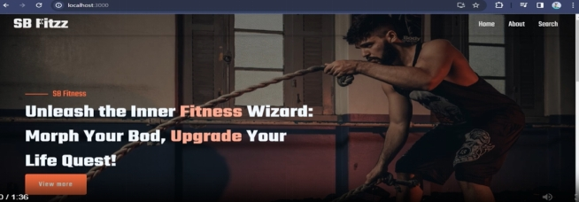

SEARCH PAGE
Here we can search many different modules of application

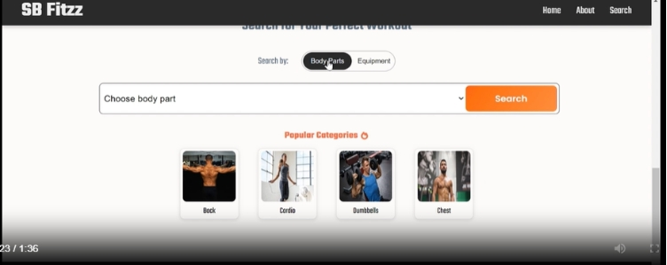

The exercise page contain the following exercise

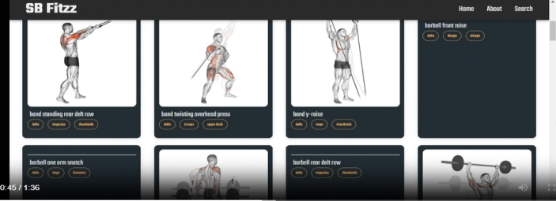

They include

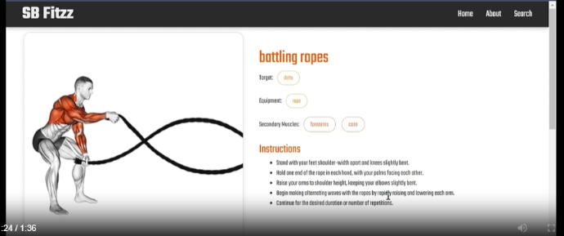
Related video
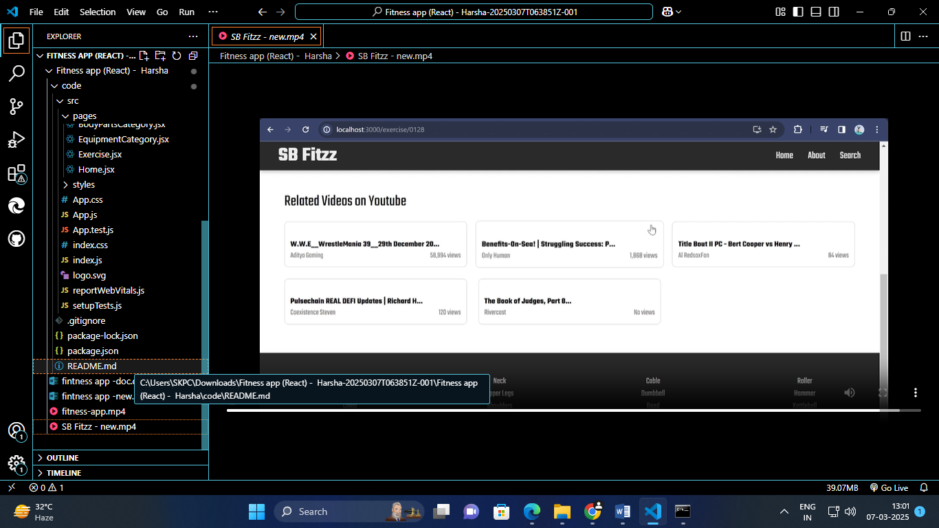
10.STYLING
Styling in FitFlex
10.1. CSS Framework
To make styling easier and more consistent across the app, you can use a CSS framework. For FitFlex, you can choose frameworks like Bootstrap, Material-UI, or Tailwind CSS. These frameworks offer pre-designed components and utilities, helping you focus more on functionality.
- Bootstrap: Offers grid systems, pre-designed components, and utility classes.
- Material-UI: Provides ready-to-use React components with a Material Design style.
- Tailwind CSS: A utility-first CSS framework that gives you fine control over styling.
If you're using Tailwind CSS, for example, you'd set up utilities directly in your JSX, like this:
<div className="bg-blue-500 text-white p-4">
<h1 className="text-2xl">FitFlex</h1>
</div>
You can add Bootstrap or Tailwind CSS to your app with simple imports or npm installations:
npm install bootstrap // For Bootstrap
npm install tailwindcss // For Tailwind CSS
2. Custom Styling with CSS
In your example, you’ve used CSS to style your app. This is where you define your global styles, such as the font-family and margins.
In your App.css file:
@import url('https://fonts.googleapis.com/css2?family=Poppins:wght@200;300;400;500;600;700;800;900&family=Teko:wght@400;600;700&family=Whisper&display=swap');

body {
margin: 0;
font-family: 'Teko', sans-serif;
-webkit-font-smoothing: antialiased;
-moz-osx-font-smoothing: grayscale;
}

code {
font-family: source-code-pro, Menlo, Monaco, Consolas, 'Courier New', monospace;
}
- Font Import: You’re importing three Google Fonts: Poppins, Teko, and Whisper.
- Global Styles: The body tag has a margin reset and sets the font-family to Teko.
You also have commented-out sections where you could use Poppins or Whisper instead, depending on the aesthetic of your app.
3. Theme Management
For theme management, it’s a good practice to define global variables for colors, typography, and other common styles. You can create a theme file or use CSS variables for this.
For example, create a theme.css file:
:root {
--primary-color: #ff6347; /* Tomato */
--secondary-color: #f0f0f0; /* Light Gray */
--font-primary: 'Poppins', sans-serif;
--font-secondary: 'Teko', sans-serif;
}

body {
font-family: var(--font-secondary);
background-color: var(--secondary-color);
}

button {
background-color: var(--primary-color);
color: white;
}
Now, use the theme in your components:
<button className="btn-primary">Click Me</button>
You can also manage themes dynamically by changing CSS variables using JavaScript (e.g., switching between light and dark themes).
4. Example App Structure
Your App.js structure looks like this:
import { Route, Routes } from 'react-router-dom';
import './App.css';
import Home from './pages/Home';
import Exercise from './pages/Exercise';
import Navbar from './components/Navbar';
import Footer from './components/Footer';
import BodyPartsCategory from './pages/BodyPartsCategory';
import EquipmentCategory from './pages/EquipmentCategory';

function App() {
return (
<div className="App">
<Navbar />
<Routes>
<Route path="/" element={<Home />} />
<Route path="/bodyPart/:id" element={<BodyPartsCategory />} />
<Route path="/equipment/:id" element={<EquipmentCategory />} />
<Route path="/exercise/:id" element={<Exercise />} />
</Routes>
<Footer />
</div>
);
}

export default App;
This structure uses the React Router for navigation and includes global styling through App.css.
10.2 THEME
Theme in FitFlex (Short)
- Purpose: Manages consistent styles like colors, fonts, and UI components across the app.
- Implementation:
  - Use CSS variables to define global styles (e.g., primary color, font family).
  - Dynamically switch themes (e.g., light/dark mode) by updating variables.
:root {
--primary-color: #ff6347; /* Tomato */
--font-family: 'Poppins', sans-serif;
}

body {
font-family: var(--font-family);
background-color: var(--primary-color);
}
- Dynamic Theme: Change values of CSS variables via JavaScript to switch themes.

11.TESTING
Testing in the Code
The testing in this code is done using the @testing-library/react library, which is commonly used in React applications to ensure components render correctly and behave as expected. The testing involves rendering the App component and checking if specific elements exist within the rendered output.
Testing Strategy and Code Coverage in FitFlex (Crisp)
11.1. Testing Strategy
Goal: Ensure that the FitFlex application works as expected, including UI, logic, and APIs, with high reliability.
- Unit Testing: Test individual components and functions for correctness (e.g., checking if a button renders properly or a function returns the expected value).
  - Tools: Jest, React Testing Library (for React components).
- Integration Testing: Test interactions between components (e.g., ensuring that data passed between components is handled correctly).
  - Tools: Jest, React Testing Library.
- End-to-End (E2E) Testing: Test the entire app, from user interactions to API calls, to ensure everything works as expected.
  - Tools: Cypress, Playwright.
- API Testing: Ensure backend APIs work correctly.
  - Tools: Jest (mocking API calls), Supertest (for testing REST APIs).
- Snapshot Testing: Test component output to ensure UI consistency.
  - Tools: Jest with React Test Renderer.
11.2. Code Coverage
Goal: Ensure all code paths are tested, and no critical functionality is left untested.
- What to Measure:
  - Function Coverage: Ensure all functions are called during tests.
  - Line Coverage: Ensure all lines of code are executed.
  - Branch Coverage: Ensure all code branches (if-else conditions) are tested.
- Tools:
  - Jest provides built-in support for code coverage:
  - jest --coverage
  - Istanbul/NYC for coverage reporting in JavaScript projects.
  - Visualize coverage using Coveralls or Codecov for continuous integration.
3. Best Practices
- Write tests early to catch errors and improve development speed.
- Mock dependencies (e.g., APIs, external libraries) in unit tests.
- Use descriptive test names and assertions to make tests readable and maintainable..

12.SCREENSHOTS OR DEMO
Demo link: https://drive.google.com/file/d/1mMqMb41RtroiFbUQ1ZfeYfWJZ6okSNb/view?usp=sharing
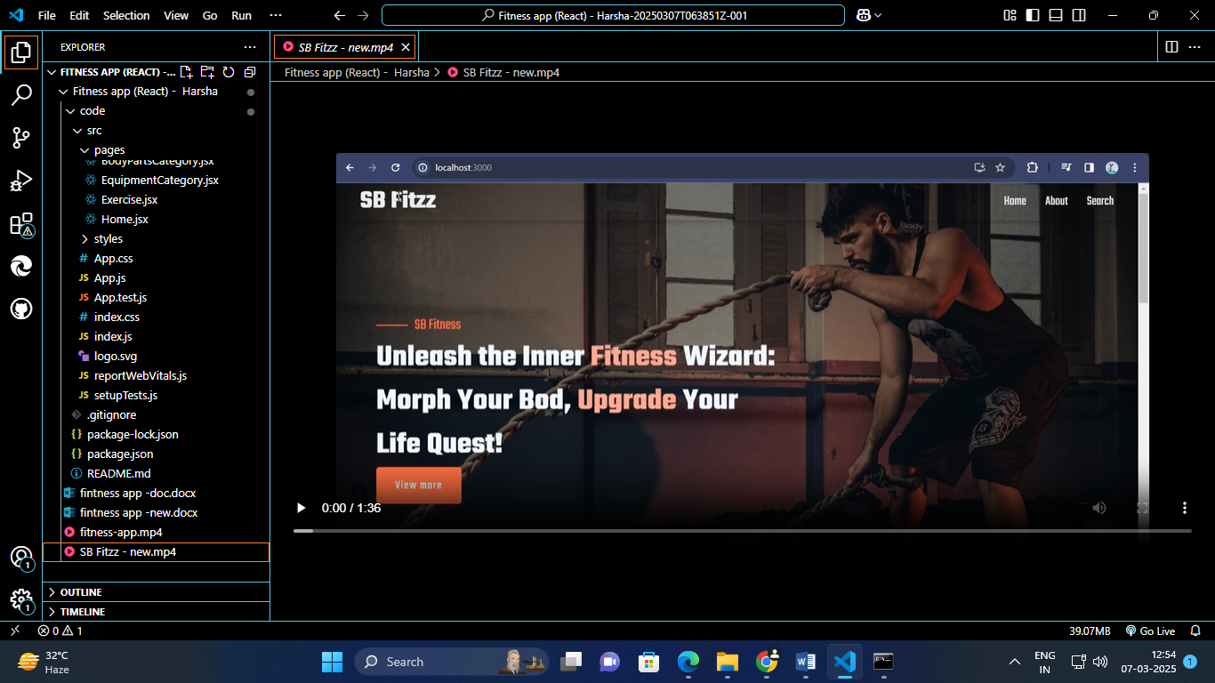
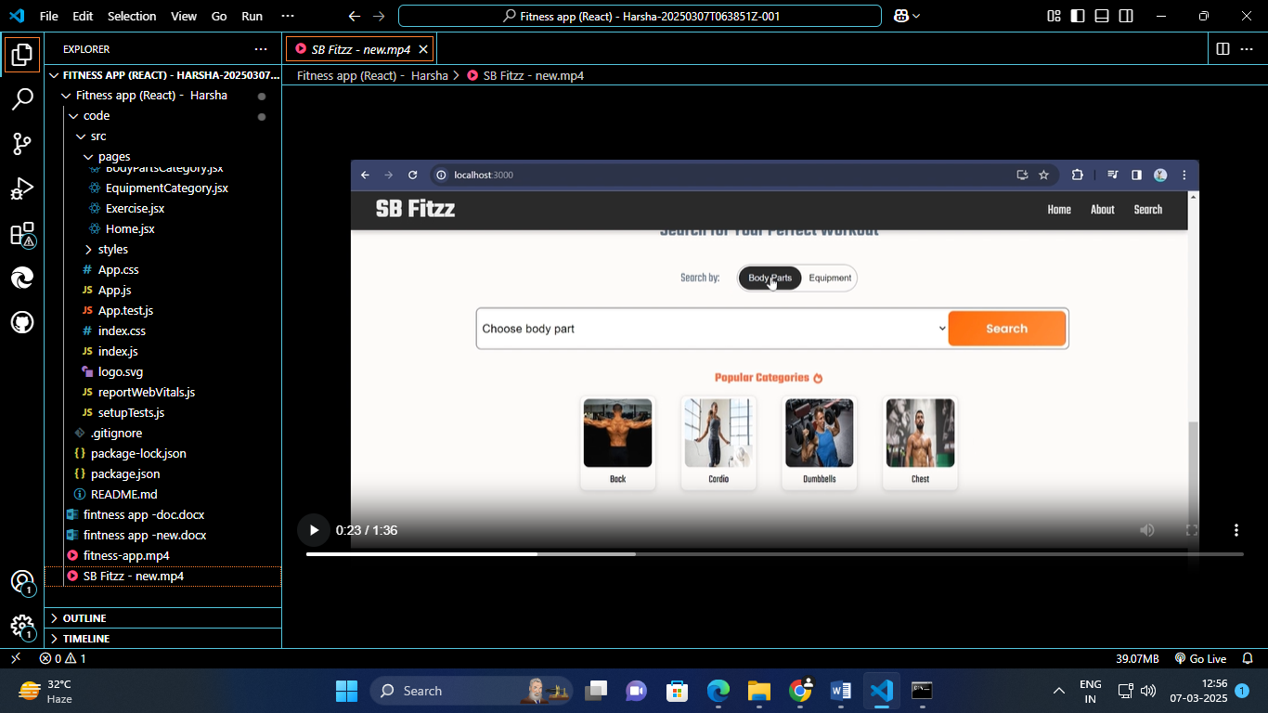
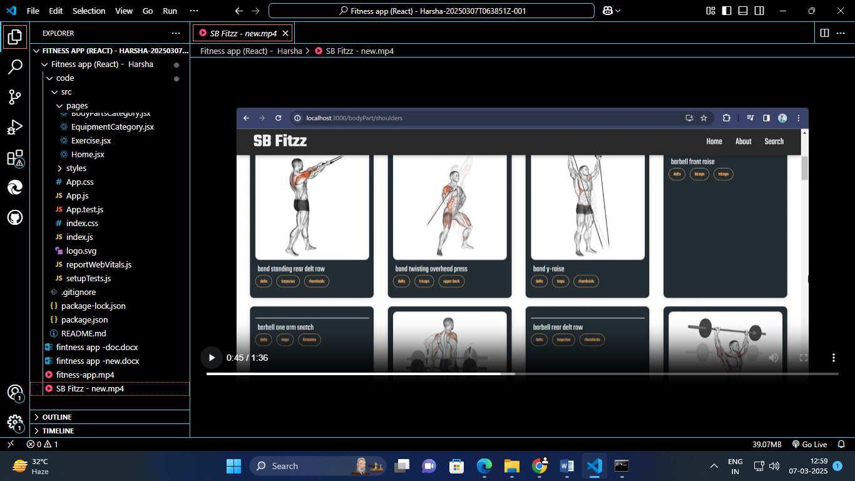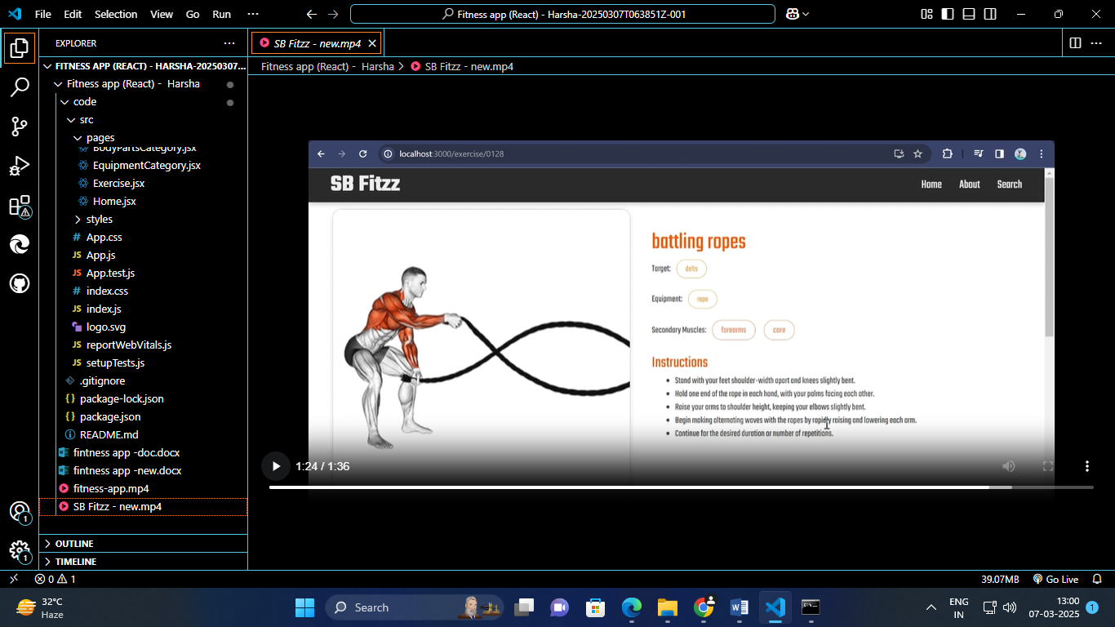
13.KNOWN ISSUES
Known Issues for FitFlex
- Authentication Delays:
  - Issue: User login may experience delays due to slow network requests or API response times.
  - Solution: Implement better error handling and loading indicators for a smoother user experience.
- UI Responsiveness on Older Devices:
  - Issue: The app may not render correctly on older devices or browsers.
  - Solution: Test and optimize the app for a wider range of devices and browsers. Use CSS media queries and Flexbox for better responsiveness.
- State Syncing Across Pages:
  - Issue: Sometimes, changes in state (e.g., workout progress or user data) do not reflect across different pages immediately.
  - Solution: Ensure that global state management (via Context API or Redux) is set up correctly for consistent data flow.
- Video Player Lag:
  - Issue: The embedded video player for exercises may experience lag or buffering.
  - Solution: Improve video streaming performance by optimizing the video quality or using a more efficient video hosting service.
- Search Functionality Bug:
  - Issue: Search results may be inaccurate or incomplete when filtering exercises by body part or equipment.
  - Solution: Improve the search algorithm and ensure the backend API returns precise results based on user input.
- Dark Mode Not Fully Implemented:
  - Issue: Some components may not switch correctly to dark mode due to incomplete theme management.
  - Solution: Ensure the app is fully integrated with dark mode settings and applies it globally.

14.FEATURE ENHANCEMENT
Feature Enhancements for FitFlex
1.Personalized Workout Recommendations
  - Enhancement: Implement a feature that suggests personalized workout plans based on user preferences, fitness goals, and workout history.
  - Benefit: Improves user experience by offering tailored content, leading to better engagement and satisfaction.
- Social Sharing & Community Integration
  - Enhancement: Add social sharing features to allow users to share their progress, achievements, or workouts on platforms like Instagram, Facebook, or Twitter.
  - Benefit: Encourages social interaction and can help attract new users through word-of-mouth and user-generated content.
- Advanced Progress Tracking (Graph & Statistics)
  - Enhancement: Include more advanced progress tracking tools like detailed charts, graphs, and metrics that track performance over time (e.g., strength, endurance, calories burned).
  - Benefit: Provides users with a visual representation of their progress, motivating them to continue their fitness journey.
- In-App Workout Challenges
  - Enhancement: Introduce monthly or weekly workout challenges that users can join and compete with others to achieve specific goals.
  - Benefit: Creates a competitive and fun environment, encouraging more active participation and user retention.
- Voice-Controlled Guidance During Workouts
  - Enhancement: Add a voice assistant that guides users through workouts, providing instructions, timing, and encouragement.
  - Benefit: Enhances usability, allowing users to focus more on their workout without needing to look at the screen constantly.
- Gamification Elements
  - Enhancement: Add gamification features like achievement badges, levels, and rewards for completing workouts or reaching milestones.
  - Benefit: Increases user engagement and motivation by turning fitness into a more enjoyable and rewarding experience.
- Integration with Wearables and Fitness Devices
  - Enhancement: Allow integration with wearable devices (like Fitbit, Apple Watch) and fitness trackers to sync health data, such as heart rate, calories burned, and steps taken.
  - Benefit: Provides users with a seamless experience by consolidating their fitness data into one platform, enhancing overall usability.
- Multi-Language Support
  - Enhancement: Implement multi-language support to cater to a global audience.
  - Benefit: Expands user reach, making FitFlex accessible to a diverse user base across different regions.
- Offline Mode
  - Enhancement: Introduce an offline mode where users can access their workouts, logs, and progress without needing an internet connection.
  - Benefit: Increases app usability, especially for users with unreliable internet connections.
- Customizable Workout Plans
  - Enhancement: Allow users to create and customize their workout plans based on specific goals (e.g., weight loss, strength building, flexibility).
  - Benefit: Provides more flexibility for users who prefer a tailored workout routine that suits their individual needs.

